Suzanne Vega
Suzanne Nadine Vega (born July 11, 1959) is an American singer-songwriter, musician and record producer, best known for her eclectic folk-inspired music.[1][2]  Vega's music career spans more than 30 years. She came to prominence in the mid 1980s, releasing four singles that entered the Top 40 charts in the UK during the 1980s and 1990s, including "Marlene on the Wall", "Left of Center", "Luka" and "No Cheap Thrill". "Tom's Diner," which was originally released as an a cappella recording on Vega's second album, Solitude Standing, was remixed in 1990 as a dance track by English electronic duo DNA with Vega as featured artist, and it became a Top 10 hit in over five countries. The song was used as a test during the creation of the MP3 format.[3]  Vega has released nine studio albums to date, the latest of which is Lover, Beloved: Songs from an Evening with Carson McCullers, released in 2016.  Tom’s diner  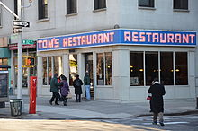  The "Tom's Diner" of the song is Tom's Restaurant in New York City,[3][4] a diner on the corner of Broadway and 112th Street. Singer and songwriter Suzanne Vega was reputedly a frequent patron of the eatery during the early 1980s when she was a student at nearby Barnard College.[5] The mid-twentieth century diner would later become famous as the location used for the exterior scenes of Monk's Café in the popular 1990s television sitcom Seinfeld.[5]  The song begins with the narrator stopping at a diner for a cup of coffee and describes a woman she sees through the window and article about a dead actor.  Vega wrote the song based on a comment by her friend Brian Rose, a photographer, who mentioned that in his work, he sometimes felt as if "he saw his whole life through a pane of glass, and [...] like he was the witness to a lot of things, but was never really involved in them." She attempted to think and write in this fashion (including a male perspective[3]) while sitting at Tom's Restaurant. The "bells of the cathedral" that she remarks hearing in the song are those of the Cathedral of Saint John the Divine, located one block to the east.  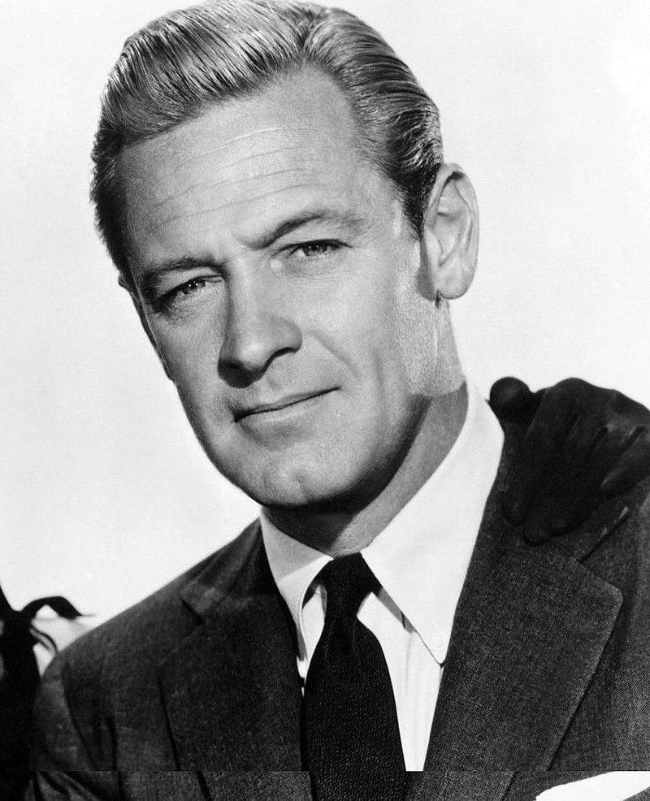  The lyrics of the song refer to a rainy morning, when she was at the diner on the corner, reading in her newspaper of "a story of an actor / who had died while he was drinking", and afterwards "turning to the horoscope / and looking for the funnies". Only two newspapers in New York City carried comic strips, or "funnies," in 1981 and 1982, and only one, the New York Post, featured a front-page story of the death of Oscar-winning actor William Holden, whose body was discovered on Monday, November 16, 1981. He had died from a fall at his apartment, suffered after drinking excessively. | Suzanne Nadine Vega (nata l’11 luglio 1959) è una cantautrice, musicista e produttrice musicale, conosciuta sopratutto per la sua musica eclettica di ispirazione fok.  La sua carriera musicale abbraccia un arco di piu’ di 30 anni. Si mise in evidenza a metà degli anni 1980s, rilasciando 4 singoli che entrarono nella lista dei Top 40 in Inghilterra

Suzanne Vega

Sono seduta di mattina
I am sitting In the morning
Alla tavola calda all’angolo
At the diner on the corner
sto aspettando al bancone
I am waiting at the counter
Che l’uomo versi il caffè
For the man to pour the coffee
Nota: il verbo “to wait” prende la preposizione “for”. Se seguito da una oggettiva, si costruisce come nell’esempio
E lo riempie solo a metà
And he fills it only halfway
E neanche faccio at tempo a discutere (lett. Prima che io neanche discuta)
And before I even argue
Guarda fuori dalla vetrinra
He is looking out the window
A qualcuno che entra
At someone coming in
“E’ sempre bello vederti
"It is always nice to see you"
Dice l’uomo dietro il bancone
Says the man behind the counter
Alla donna che è entrata
To the woman who has come in
Sta scuotendo her umbrella
She is shaking ger umbrella
E guardo dall’altra parte
And I look the other way
Mentre si baciano i loro saluti
As they are kissing their hellos
E faccio finta di non vederli
I'm pretending Not to see them
E invece verso il latte
And instead I pour the milk
Apro il giornale
I open up the paper
C’è la storia di un attore
There's a story of an actor
Che era morto mentre beveva
Who had died while he was drinking
Non era uno di cui avevo sentito
He was no one I had heard of
E mi rivolgo all’oroscopo
And I'm turning To the horoscope
E cerco i cartoni
And looking For the funnies
Quando sento qualcuno che mi guarda
When I'm feeling Someone watching me
E così alzo la testa
And so I raise my head
C’è una donna di fuori
There's a woman On the outside
Che guarda dentro, mi vede?
Looking inside, does she see me?
No, non mi vede veramente
No she does not Really see me
Perchè vede il proprio riflesso
Cause she sees Her own reflection
E sto cercando di non far caso
And I'm trying Not to notice
Che si sta sistemando la gonna
That she's hitching Up her skirt
E mentre si stira le calze
And while she's Straightening her stockings
I suoi capelli si stanno bagnando
Her hair Is getting wet
Oh, questa pioggia continuerà
Oh, this rain It will continue
Per la mattina mentre sto ascoltando
Through the morning As I'm listening
Le campane della cattedrale
To the bells Of the cathedral
Sto pensando alla tua voce
I am thinking Of your voice
E al picnic di mezzanotte una volta tanto tempo fa
And of the midnight picnic Once upon a time
Prima che la pioggia cominciasse
Before the rain began
Finisco il mio caffè ed è ora di prendere il treno
I finish up my coffee and it's time to catch the train

