Suzanne Vega

Suzanne Nadine Vega (born July 11, 1959) is an American singer-songwriter, musician and record producer, best known for her eclectic folk-inspired music.[1][2]

Vega's music career spans more than 30 years. She came to prominence in the mid 1980s, releasing four singles that entered the Top 40 charts in the UK during the 1980s and 1990s, including "Marlene on the Wall", "Left of Center", "Luka" and "No Cheap Thrill". "Tom's Diner," which was originally released as an a cappella recording on Vega's second album, Solitude Standing, was remixed in 1990 as a dance track by English electronic duo DNA with Vega as featured artist, and it became a Top 10 hit in over five countries. The song was used as a test during the creation of the MP3 format.[3]

Vega has released nine studio albums to date, the latest of which is Lover, Beloved: Songs from an Evening with Carson McCullers, released in 2016.

Tom’s diner

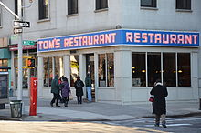
The "Tom's Diner" of the song is Tom's Restaurant in New York City,[3][4] a diner on the corner of Broadway and 112th Street. Singer and songwriter Suzanne Vega was reputedly a frequent patron of the eatery during the early 1980s when she was a student at nearby Barnard College.[5] The mid-twentieth century diner would later become famous as the location used for the exterior scenes of Monk's Café in the popular 1990s television sitcom Seinfeld.[5]
The song begins with the narrator stopping at a diner for a cup of coffee and describes a woman she sees through the window and article about a dead actor.

Vega wrote the song based on a comment by her friend Brian Rose, a photographer, who mentioned that in his work, he sometimes felt as if "he saw his whole life through a pane of glass, and [...] like he was the witness to a lot of things, but was never really involved in them." She attempted to think and write in this fashion (including a male perspective[3]) while sitting at Tom's Restaurant. The "bells of the cathedral" that she remarks hearing in the song are those of the Cathedral of Saint John the Divine, located one block to the east.

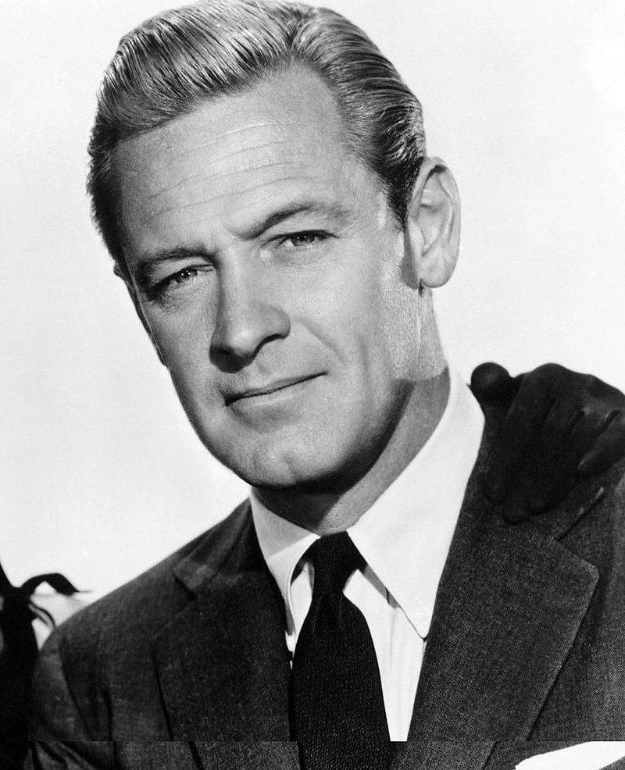
The lyrics of the song refer to a rainy morning, when she was at the diner on the corner, reading in her newspaper of "a story of an actor / who had died while he was drinking", and afterwards "turning to the horoscope / and looking for the funnies". Only two newspapers in New York City carried comic strips, or "funnies," in 1981 and 1982, and only one, the New York Post, featured a front-page story of the death of Oscar-winning actor William Holden, whose body was discovered on Monday, November 16, 1981. He had died from a fall at his apartment, suffered after drinking excessively.

Suzanne Vega

I am sitting
In the morning
At the diner
On the corner
I am waiting
At the counter
For the man
To pour the coffee
And he fills it
Only halfway
And before
I even argue
He is looking
Out the window
At somebody
Coming in
"It is always
Nice to see you"
Says the man
Behind the counter
To the woman
Who has come in
She is shaking
Her umbrella
And I look
The other way
As they are kissing
Their hellos
I'm pretending
Not to see them
And Instead
I pour the milk
I open
Up the paper
There's a story
Of an actor
Who had died
While he was drinking
He was no one
I had heard of
And I'm turning
To the horoscope
And looking
For the funnies
When I'm feeling
Someone watching me
And so
I raise my head
There's a woman
On the outside
Looking inside
Does she see me?
No she does not
Really see me
Cause she sees
Her own reflection
And I'm trying
Not to notice
That she's hitching
Up her skirt
And while she's
Straightening her stockings
Her hair
Is getting wet
Oh, this rain
It will continue
Through the morning
As I'm listening
To the bells
Of the cathedral
I am thinking
Of your voice
And of the midnight picnic
Once upon a time
Before the rain began
I finish up my coffee
It's time to catch the train

